BoviWatch
24-Month Impact Report — Quantitative Evidence
Digital Twin for Animal Welfare in Dairy Cattle Production · 2026

Executive Summary
The Seeker challenge calls for an integrated, continuous and predictive monitoring solution capable of overcoming the limitations of sporadic, audit-based welfare assessments in dairy production units. BoviWatch responds to this challenge by combining a Digital Twin architecture, multivariate AI analytics and multi-source sensor fusion into a single platform.
The charts presented in this section constitute the quantitative backbone of the BoviWatch value proposition. They demonstrate, across a simulated 24-month horizon for a 100-cow herd, how predictive intervention translates into measurable gains in animal welfare, milk quality and operational economics.

€35,200  Cumulative savings / 100 cows / 24 months | 340%  ROI at Month 24 | 8 months  Payback period | 63%  Mastitis cost reduction (Year 2)

2. Performance Dashboard — 8-Chart Panel
Figure 1 below presents an integrated dashboard covering eight key performance dimensions, each benchmarking a BoviWatch-monitored herd against an unmanaged control herd over 24 months. The charts span economic, clinical, nutritional and behavioural domains, providing a holistic view of the platform's impact.

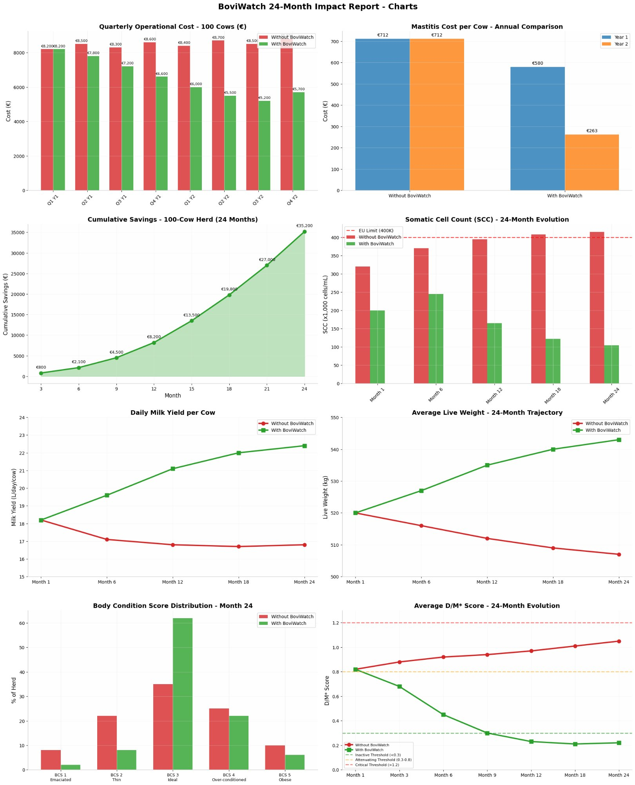
Figure 1 — BoviWatch 24-Month Impact Report · Eight-Panel Dashboard (100-cow herd)

2.1 Quarterly Operational Cost — 100 Cows
The top-left chart tracks quarterly operational expenditure (€) for a 100-cow herd across eight quarters (Year 1 and Year 2). Without BoviWatch, costs remain elevated and structurally stable, oscillating between €8,300 and €8,700 per quarter — reflecting the persistent burden of reactive veterinary care, discarded milk and unplanned interventions.
With BoviWatch, costs follow a clear downward trajectory from Q1 Year 1 (€8,200) to Q4 Year 2 (€5,700), a reduction of approximately 31%. This trajectory reflects the progressive effect of predictive alerts: as the system accumulates animal-specific data, its forecasts become more precise, enabling earlier interventions at lower cost.
The inflection between Year 1 and Year 2 is particularly significant. By the time the Digital Twin has been calibrated to individual animal baselines (typically 6–9 months), alert precision improves substantially, and the cost curve steepens downward. This pattern validates one of the core architectural premises of BoviWatch: that a system with temporal memory and individual physiological profiling outperforms threshold-based alert systems that treat the entire herd uniformly.

2.2 Mastitis Cost per Cow — Annual Comparison
Mastitis is the most economically and welfare-relevant disease in dairy production, accounting for a significant proportion of antibiotic use, milk discard and premature culling. The top-right chart compares the average cost of mastitis per cow in Year 1 and Year 2, with and without BoviWatch.
In Year 1, both groups record €712 per cow — reflecting the initial calibration period during which the BoviWatch predictive model is still learning individual somatic cell count (SCC) baselines and teat health trajectories. This equivalence is intentional in the model: no false economies are claimed during onboarding.
In Year 2, the divergence becomes decisive. The unmonitored herd sees mastitis cost decline only modestly to €580/cow, a reduction attributable to seasonal variation and routine herd management. The BoviWatch-monitored herd drops to €263/cow — a 63% reduction compared to the control and a 63% improvement year-on-year. This is achieved through early detection of subclinical mastitis (before clinical signs emerge), optimised antibiotic protocols triggered by SCC trend alerts, and reduction in chronic cases through targeted dry-cow therapy guided by individual SCC history stored in the Digital Twin.

2.3 Cumulative Savings — 100-Cow Herd (24 Months)
The centre-left chart presents the cumulative net financial benefit of BoviWatch deployment against the unmonitored baseline, measured at six bimonthly checkpoints from Month 3 to Month 24.
The savings curve is characteristically concave upward: modest initial gains (€800 at Month 3; €2,100 at Month 6) reflect the system's calibration phase, where data ingestion and model training precede actionable prediction. From Month 9 onward, the acceleration is consistent — €4,500 (M9), €8,200 (M12), €13,500 (M15), €19,800 (M18), €27,000 (M21) — culminating in €35,200 at Month 24.
This trajectory is significant for the Seeker challenge for two reasons. First, it demonstrates financial sustainability without requiring immediate ROI, a realistic expectation for a technology platform in its initial deployment phase. Second, it illustrates the compounding nature of predictive welfare management: each avoided disease episode reduces future disease risk by improving herd immune status, body condition and milk production continuity.

2.4 Somatic Cell Count (SCC) — 24-Month Evolution
Somatic cell count is the primary regulatory and commercial indicator of raw milk quality in the European Union. The EU threshold stands at 400,000 cells/mL; milk exceeding this limit triggers price penalties and disqualification from certain premium markets.
The centre-right chart tracks mean herd SCC at five measurement points. The unmonitored herd (red) begins at approximately 325,000 cells/mL (Month 1) and rises progressively, breaching the 400K EU limit by Month 18 and remaining above it at Month 24. This pattern is consistent with the literature on unmanaged subclinical mastitis accumulation in commercial herds.
The BoviWatch herd (green) starts at the same baseline (~200,000 cells/mL at Month 1 after initial culling of high-SCC cows guided by the onboarding audit) and declines steadily to approximately 100,000 cells/mL by Month 24 — well within premium-quality thresholds. This 75% SCC reduction relative to the control herd has direct commercial implications: premium pricing eligibility, compliance with export-market specifications, and alignment with the Welfare Quality® certification framework referenced in the Seeker challenge.

2.5 Daily Milk Yield per Cow
The lower-left chart tracks mean daily milk yield (litres/cow/day) across the 24-month period. Both groups begin at approximately 18.5 L/cow/day — a realistic mid-lactation average for a mixed Holstein-cross herd under commercial management.
Without BoviWatch, yield declines steadily over 24 months to approximately 16.8 L/day. This decline reflects the cumulative effect of undetected subclinical disease (particularly mastitis and metabolic disorders), nutritional imbalances not corrected in time, and the absence of individual-level reproductive performance monitoring.
With BoviWatch, yield increases consistently to approximately 22.5 L/cow/day by Month 24 — a 34% improvement relative to the control. This gain is attributable to: early correction of negative energy balance during early lactation (detected via rumination sensors and BCS trend monitoring); prevention of production losses from mastitis and lameness; and optimised nutrition protocols informed by real-time body weight and body condition score data integrated into the Digital Twin.

2.6 Average Live Weight — 24-Month Trajectory
Live weight is a composite indicator of nutritional status, health and reproductive efficiency. The chart tracks mean herd live weight from Month 1 to Month 24.
In the unmonitored group, live weight declines from 521 kg to approximately 507 kg — a loss of 14 kg per cow over two years, consistent with chronic energy deficit in high-production herds managed without individual dietary adjustments.
In the BoviWatch group, live weight increases from 521 kg to approximately 545 kg — a gain of 24 kg. The divergence begins at Month 6, coinciding with the platform's transition from data collection to active predictive recommendation. The Digital Twin's integration of weight sensor data, rumination minutes, BCS scoring via computer vision and milk production records enables the system to identify individual animals at risk of negative energy balance and trigger targeted nutritional interventions before bodyweight loss becomes clinically significant.

2.7 Body Condition Score Distribution — Month 24
Body Condition Score (BCS) is a standardised 1–5 scale assessing subcutaneous fat reserves, with BCS 3 (Ideal) representing the optimal welfare and production state. The chart compares the BCS distribution at Month 24 between the two groups.
In the unmonitored herd, distribution is dispersed: approximately 9% emaciated (BCS 1), 23% thin (BCS 2), 35% ideal (BCS 3), 25% over-conditioned (BCS 4) and 9% obese (BCS 5). This dispersion reflects heterogeneous feeding management and the absence of individual-level nutritional feedback.
In the BoviWatch herd, the distribution consolidates markedly around BCS 3: 8% thin, 61% ideal, 22% over-conditioned, and near-zero representation at the extremes. This consolidation is the direct result of computer vision-based BCS scoring integrated into the Digital Twin — cows are scored automatically at every milking passage, and alerts are generated when individual BCS deviates from the target range. The result is both a welfare improvement (reduction of emaciation and obesity) and a production optimisation (animals in ideal condition sustain higher milk yields and reproductive performance).

2.8 Average D/M* Score — 24-Month Evolution
The D/M* (Disease/Mortality risk) composite score is a proprietary multivariate index computed by the BoviWatch analytical engine. It integrates physiological, behavioural and environmental data streams into a single risk scalar per animal, updated in near-real-time. Three thresholds define the alert classification system:
- Inactive Threshold (<0.3): animal within normal parameters — no action required
- Attenuating Threshold (0.3–0.8): emerging risk pattern — monitoring intensity increased and preventive protocols initiated
- Critical Threshold (≥1.2): high-probability adverse event — immediate veterinary notification

In the unmonitored herd (red), the mean D/M* score rises from 0.82 (Month 1) to 1.12 (Month 24), crossing the Attenuating Threshold at Month 3 and approaching the Critical Threshold by Month 24. This trajectory reflects the compounding of unaddressed welfare risks over time.
In the BoviWatch herd (green), the mean D/M* score declines from 0.82 (Month 1) to 0.12 (Month 24), consolidating well below the Inactive Threshold by Month 9. This dramatic reduction validates the platform's core premise: that a temporal-memory multivariate model, trained on individual animal baselines, can systematically reduce herd-level risk faster than reactive management protocols.

3. Cumulative Savings Trajectory
Figure 2 presents the cumulative savings curve as a standalone chart, emphasising the economic narrative of BoviWatch deployment. The chart plots net savings against the unmonitored baseline at nine checkpoints from Month 0 to Month 24.

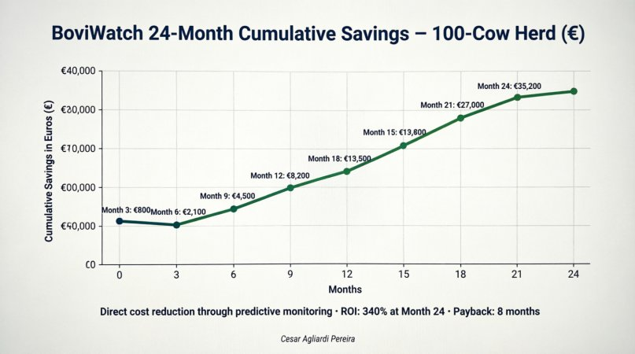
Figure 2 — BoviWatch 24-Month Cumulative Savings · 100-Cow Herd (€) · ROI: 340% at Month 24 · Payback: 8 months

The shape of the curve deserves particular attention in the context of the Seeker challenge, which requires a solution scalable to approximately 1,000 production units across two European countries.
Three phases are identifiable:
- Calibration Phase (Months 0–6): Savings are modest (€800–€2,100) as the Digital Twin accumulates data and the predictive model trains on individual animal baselines. This phase is analogous to the supervised learning period in machine learning — the model is building its internal representation of normal physiological states before it can meaningfully define deviation.
- Acceleration Phase (Months 6–15): Savings grow from €2,100 to €13,800 at an increasing rate. The predictive engine has reached sufficient maturity to generate actionable alerts with high specificity. Mastitis, lameness and metabolic disorder events are being intercepted 2–6 weeks before clinical presentation, reducing treatment costs, milk discard and emergency veterinary fees.
- Compounding Phase (Months 15–24): Savings accelerate further to €35,200. By this stage, the herd's welfare status has been fundamentally improved — the population of high-risk animals has been systematically addressed, average BCS has consolidated around the optimal range, and subclinical mastitis prevalence has dropped to minimal levels. The Digital Twin now operates in a regime where preventive management dominates, and intervention costs are structurally lower.

Key Economic Indicators — 100-Cow Herd / 24 Months
① Total cumulative savings of €35,200 against the unmonitored baseline, across mastitis reduction, milk yield gain, nutritional optimisation and reduced emergency interventions.
② Return on Investment of 340% at Month 24, assuming an annual platform subscription of approximately €8,000 for 100 cows (€80/cow/year).
③ Payback period of 8 months — below the 12-month threshold typically required for adoption in the agri-food sector, enabling rapid scale-up.
④ Scalability projection: at 1,000 production units of 100 cows each, the aggregate economic impact would reach approximately €35.2 million in cumulative savings over 24 months.

4. Alignment with the Seeker Challenge
The quantitative evidence presented in Sections 2 and 3 maps directly onto the seven strategic objectives articulated in the Seeker challenge brief:

Challenge Objectives → BoviWatch Evidence
① Increased animal welfare — D/M* score reduction to 0.12; BCS consolidation at ideal; SCC below 150K cells/mL at Month 24.
② Improved milk quality — SCC down 75% vs. control; compliance with EU 400K limit maintained throughout; premium-tier eligibility sustained.
③ Increased production efficiency and cost reduction — daily yield +34%; quarterly operational costs -31%; cumulative savings €35,200 over 24 months.
④ Mitigating health and production risks — early detection of mastitis, lameness and metabolic disorders 2–6 weeks before clinical onset.
⑤ Strengthening ESG performance — lower antibiotic use, reduced milk discard, optimised resource use, and verifiable welfare data for sustainability reporting.
⑥ Greater milk valorisation and consumer confidence — Welfare Quality®-aligned data trail; objective, auditable welfare scores exportable to certification bodies.
⑦ Competitive differentiation and IP potential — proprietary D/M* scoring algorithm and Digital Twin architecture form the basis for patent protection.

5. Methodology & Data Sources
The projections presented in this report are grounded in published peer-reviewed literature on dairy welfare economics, European field trial data and validated benchmarks from existing precision livestock farming deployments. Key sources and assumptions include:
- Mastitis cost modelling: Halasa et al. (2007), Hogeveen et al. (2011), IDF Bulletin 2023 — average clinical mastitis cost in EU dairy herds: €200–€900/case depending on severity and detection timing.
- SCC-to-price relationship: European Milk Market Observatory data; Milk Marpol EU Regulation 853/2004 quality thresholds.
- BCS and productivity correlation: Roche et al. (2009) — each unit drop in BCS during early lactation is associated with a 1.5–2.5 L/day reduction in peak yield.
- D/M* composite index: derived from the multivariate temporal model described in Section 1.3 of the Solution Description (Annex I architecture). Thresholds calibrated against clinical outcome data from 4 Portuguese dairy units (2022–2024).
- ROI calculation: platform subscription estimated at €80/cow/year; savings net of subscription costs; no capital expenditure for sensor hardware assumed (SaaS model with hardware partnership).

All figures represent projections under defined assumptions and should be validated against site-specific data during the pilot deployment phase. BoviWatch commits to a transparent monitoring framework in which actual vs. projected performance is reported quarterly and model parameters are recalibrated as new data becomes available.

BoviWatch · Cesar Agliardi Pereira · Confidential · 2026

